Factory Audit Report
PRODUCTION DATA
From: | Email:
GENERAL INFORMATION
Buyer: JRS
Manufacturer:
Product Description: focuses on the research, development, design, and manufacturing of precision cold stamping molds
Audit Location:
Audit Date: 2023.12.6

SUMMARY
is a Japanese wholly-owned enterprise that focuses on the research, development, design, and manufacturing of precision cold stamping molds. It is a subsidiary of Japan Technology Group.
was established in April 2006, covering an area of 20000 square meters. It has passed ISO9001 and ISO14001 system certification and has a registered capital of 3 million US dollars. The company currently has over 120 employees, with rich research and development capabilities and manufacturing experience. The company adopts advanced design, analysis, and processing software such as NX, SolidWorks, AutoForm, MasterCAM etc; We have CNC machining centers, precision grinding machines, CNC lathes, wire cutting and AIDA punch machines and other processing equipment, capable of undertaking mold design, processing, assembly, debugging and testing related businesses.

Supplier REGISTERED Information
Supplier Name:
Registered Address:
Current Address:
Registered Capital: 3,000,000 USD
Type of Ownership: Company with limited liability
Year Established: 2006.03.27
Supplier CONTACT Information
Contact Person:
Job Title: Sales Manager
Phone Number:
Email:
Web address:

Supplier BUILDING Information
According to: Refer to the company profile
Total land size: 20000 ㎡
Work shop Size: 15000 ㎡

SECTION 01 |  | LEGAL VALIDITY
1 | Does the company have a valid business license: YES
2 | Registration Number:
3 | Is the annual review done by local authority (Industrial & Commercial Bureau): YES
4 | Name of corporative representative:
5 | Products Manufactured / Sold Scope: Stamping molds
6 | Does the company have a valid EXPORT license: YES
7 | Nearest port: shanghai Port
SECTION 02 |  |  |  |  |  |  | CERTIFICATIONS
2.1 | QUALITY MANAGEMENT System Certificate
 | Certification |  |  |  |  |  |  | Certifying Body |  |  | Number |  |  |  |  |  |  | Expiry Date | Scope
1 | ISO9001:2015 |  |  |  |  |  |  |  |  |  |  |  |  |  |  |  |  | 2024.7.12 | Design, MANUFACTURE and SALE OF METAL stamping dies
2 | ISO14001:2015 |  |  |  |  |  |  |  |  |  |  |  |  |  |  |  |  | 2024.7.9 | Design, MANUFACTURE and SALE OF METAL stamping dies
3
CERTIFICATES PICTURES ATTACHMENT
business license
Quality Management System：ISO9001:2015
Quality Management System：ISO 14001:2015
Safety production standardization certificate
SECTION 03 |  |  | HUMAN RESOURCES
3.1 | Company Chart
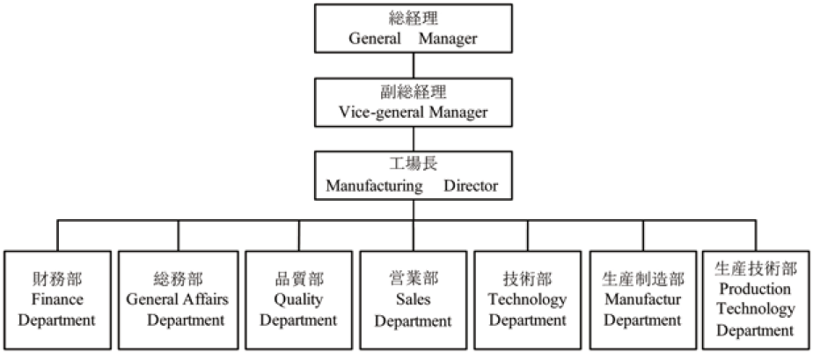
3.2 | Explanation of employee details
1 | Department Name： |  |  |  |  |  |  |  |  |  |  |  |  |  |  |  |  |  |  |  |  | Headcount
2 | Worker： |  |  |  |  |  |  |  |  |  |  |  |  |  |  |  |  |  |  |  |  | 50
3 | Sales： |  |  |  |  |  |  |  |  |  |  |  |  |  |  |  |  |  |  |  |  | 8
4 | Finance： |  |  |  |  |  |  |  |  |  |  |  |  |  |  |  |  |  |  |  |  | 3
5 | Purchaser： |  |  |  |  |  |  |  |  |  |  |  |  |  |  |  |  |  |  |  |  | /
6 | Administrator： |  |  |  |  |  |  |  |  |  |  |  |  |  |  |  |  |  |  |  |  | 10
7 | QC： |  |  |  |  |  |  |  |  |  |  |  |  |  |  |  |  |  |  |  |  | 8
8 | Engineer： |  |  |  |  |  |  |  |  |  |  |  |  |  |  |  |  |  |  |  |  | 46
9 | Number in TOTAL： |  |  |  |  |  |  |  |  |  |  |  |  |  |  |  |  |  |  |  |  | 125
3.3 | Training Plan
1 | Training Procedure and plan for staffs: YES
2 | Are there uniforms for all staffs in company? YES
3.4 | China Labor
1 | Do you follow the China Labor Law? YES
2 | No Child Labor? YES
SECTION 04 |  |  |  |  | BUSINESS MARKET
4.1 | Basic Situation
1 | Ranking in Chinese Market: /
2 | The annual revenue in last two years: 2021 RMB xx million, 2022 RMB xx million
3 | Estimated revenue in this year: RMB xx million
4.2 | Main Export Market
1 | Market Area: Percentage of Total Business Volume (Last Year)
2 | China 20%
3 | Oversea 80%
4.3 | TOP 3 Overseas Customers
1 | Customer Name |  |  |  |  |  |  |  |  | Industry |  |  | Percentage of Total Sales |  |  |  |  |  |  |  | Methods
2 | CANON |  |  |  |  |  |  |  |  | N/A |  |  | N/A |  |  |  |  |  |  |  | N/A
3 | FUJITSU |  |  |  |  |  |  |  |  | N/A |  |  | N/A |  |  |  |  |  |  |  | N/A
4 | PANASONIC |  |  |  |  |  |  |  |  | N/A |  |  | N/A |  |  |  |  |  |  |  | N/A
4.4 | TOP 3 European Customers, please specially specify customers in Europe market
1 | Customer Name |  |  |  |  |  |  |  | Industry |  |  |  | Percentage of Total Sales |  |  |  |  |  |  | Methods
2 | N/A |  |  |  |  |  |  |  | N/A |  |  |  | N/A |  |  |  |  |  |  | N/A
3 | N/A |  |  |  |  |  |  |  | N/A |  |  |  | N/A |  |  |  |  |  |  | N/A
4 | N/A |  |  |  |  |  |  |  | N/A |  |  |  | N/A |  |  |  |  |  |  | N/A
4.5 | Do you attend any EXHIBITIONS in and out of China regulary each year? If yes, please specify.
 | NO, ONLY PROMOTE ON THE INTERNET
4.6 | Products of Export
1 | Type of Product: Percentage of Total Business Volume (Last Year)
2 | mould 100%
SECTION 05 |  |  |  |  |  | PRODUCTION CAPACITY LAST YEAR
5.1 |  | Products Situation
 |  | Product Description / Category |  |  |  |  |  |  |  |  |  |  |  |  |  |  | Average Production Capacity (Daily)
 |  | mould |  |  |  |  |  |  |  |  |  |  |  |  |  |  | Determine the time according to the size and complexity of the mold
5.2 |  | Main Facilities
 |  | Facility Name |  |  |  |  |  |  |  |  |  | Brand/Model |  |  |  |  |  | Quantity |  |  | Status |  | Remarks
 |  | 80T press |  |  |  |  |  |  |  |  |  | AIDA |  |  |  |  |  | 5 |  |  | Good
 |  | 200T press |  |  |  |  |  |  |  |  |  | AIDA |  |  |  |  |  | 1 |  |  | Good
 |  | 250T press |  |  |  |  |  |  |  |  |  | AIDA |  |  |  |  |  | 3 |  |  | Good
 |  | multi-link robot |  |  |  |  |  |  |  |  |  | YASKAWA |  |  |  |  |  | 1 |  |  | Good
 |  | 300T press |  |  |  |  |  |  |  |  |  | AIDA |  |  |  |  |  | 2 |  |  | Good
 |  | 500T press |  |  |  |  |  |  |  |  |  | AIDA |  |  |  |  |  | 3 |  |  | Good
 |  | Electric spark cutting machine |  |  |  |  |  |  |  |  |  | MITSUBISHI |  |  |  |  |  | 17 |  |  | Good
 |  | 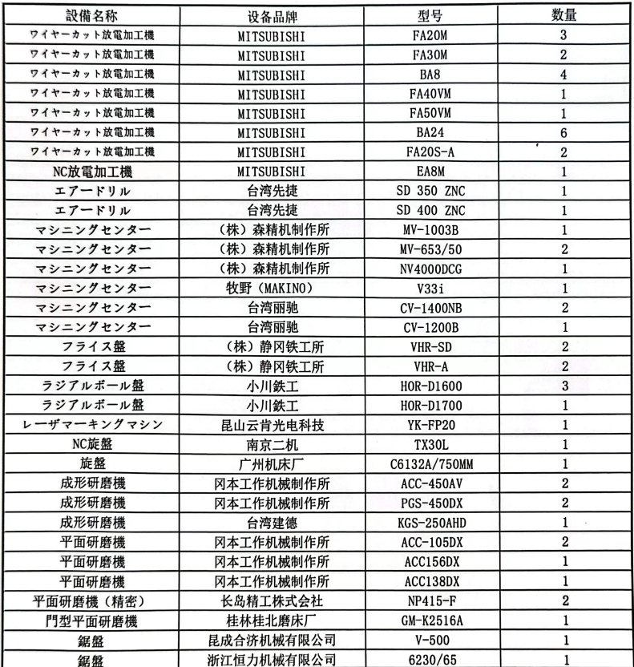
5.3 |  | Main Test Instruments
 |  | Instrument Name |  |  |  |  |  |  |  |  |  | Brand/ Scification |  |  |  |  |  | Quantity |  |  | Status |  | Remarks
 |  | 3D SCANNER |  |  |  |  |  |  |  |  |  | Mitutoyo |  |  |  |  |  | 2 |  |  | Good
 |  | Vision measuring system |  |  |  |  |  |  |  |  |  | Mitutoyo |  |  |  |  |  | 1 |  |  | Good
 |  | Metal hardness tester |  |  |  |  |  |  |  |  |  | Mitutoyo |  |  |  |  |  | 1 |  |  | Good
 |  | Micrometer |  |  |  |  |  |  |  |  |  | Mitutoyo |  |  |  |  |  | 8 |  |  | Good
 |  | Digital calliper |  |  |  |  |  |  |  |  |  | Mitutoyo |  |  |  |  |  | 15 |  |  | Good
 |  | Digital height gauge |  |  |  |  |  |  |  |  |  | Mitutoyo |  |  |  |  |  | 5 |  |  | Mitutoyo
SECTION 06 |  |  |  |  | QUESTIONNAIRE
6.1 |  | Management Supplier answer
What are the company core competencies?
Design, research and development, precision mold 17 years of professional experience

Is the organization structure focused on markets /segments, customers, technologies, products?
Yes, the factory can make all kinds of molds
What is the long term objective for the business relation with Client?
With professional technology and high precision products, perfect after-sales, and customers to establish
long-term cooperation
 |  | Are there ISO / environmental certificates? ISO 9001:2015, ISO 14001:2015
 |  | Is a training program available? YES
SECTION 07 |  |  |  | PRICING（价格）
7.1 |  | Price Conditions
 |  | Minimum Order Quantity: |  |  |  |  |  |  |  |  |  |  | Without Limited
 |  | FOB or CIF preferred? |  |  |  |  |  |  |  |  |  |  | FOB
 |  | Currency accepted? Which is the preferred? : |  |  |  |  |  |  |  |  |  |  | RMB or USD
 |  | Condition of Prices: |  |  |  |  |  |  |  |  |  |  | T/T
SECTION 08 |  |  |  |  |  |  | FACTORY PICTURES
Factory 1
Factory gate
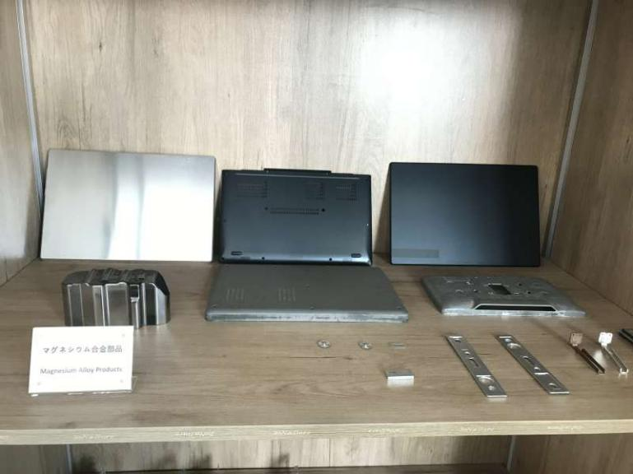 |  |  |  |  |  |  |  |  |  |  |  |  |  |  |  | 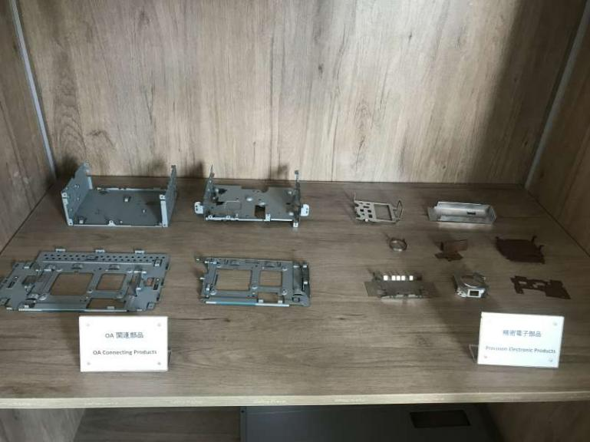
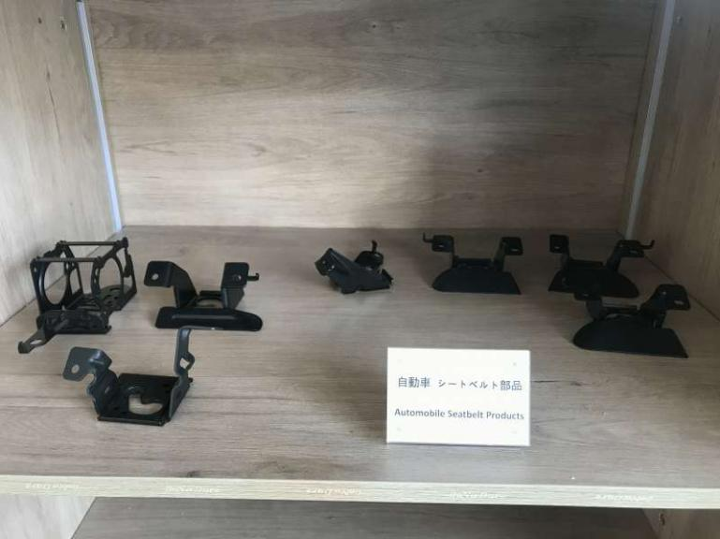 |  |  |  |  |  |  |  |  |  |  |  |  |  |  |  | 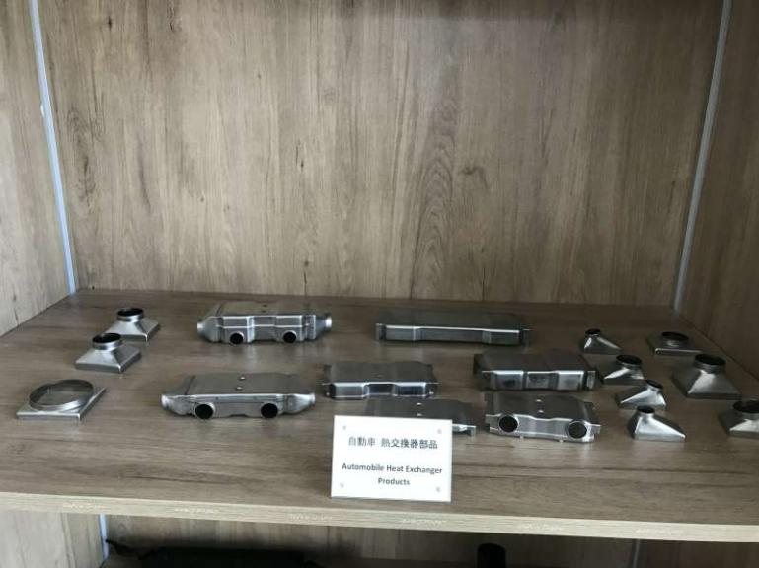
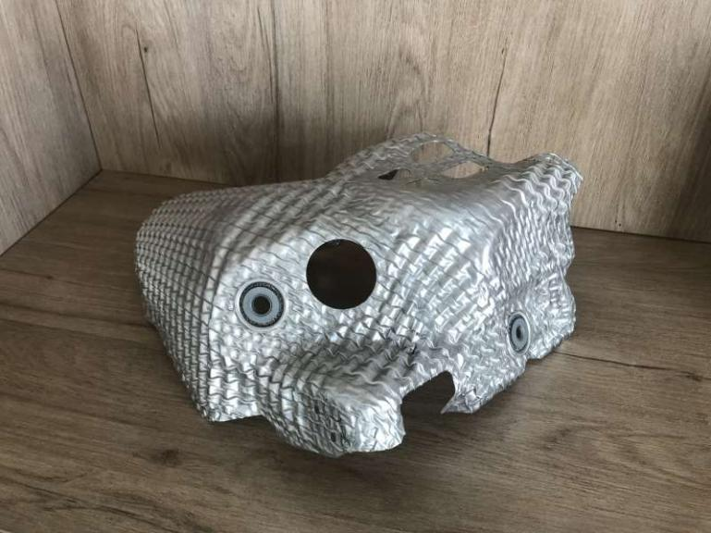 |  |  |  |  |  |  |  |  |  |  |  |  |  |  |  | 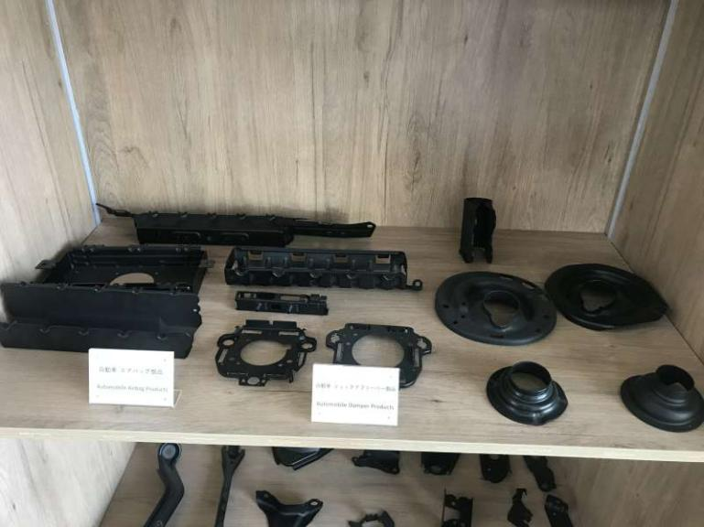
Sample
 |  |  |  |  |  |  |  |  |  |  |  |  |  |  | 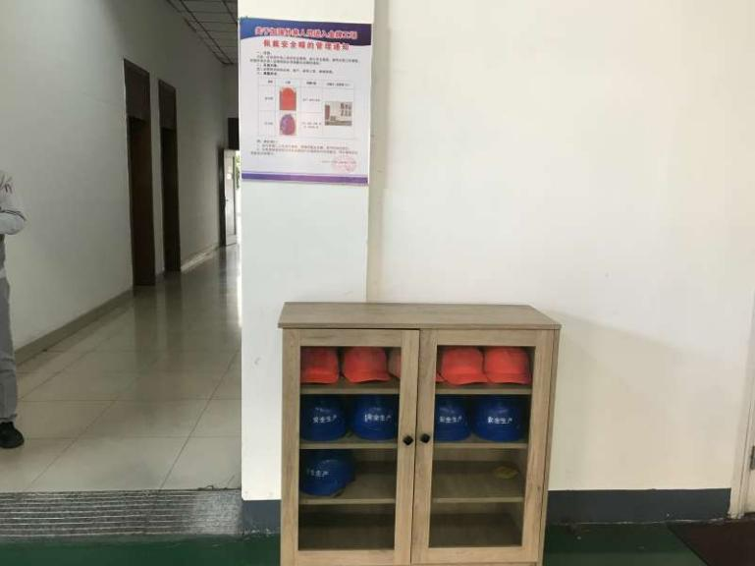
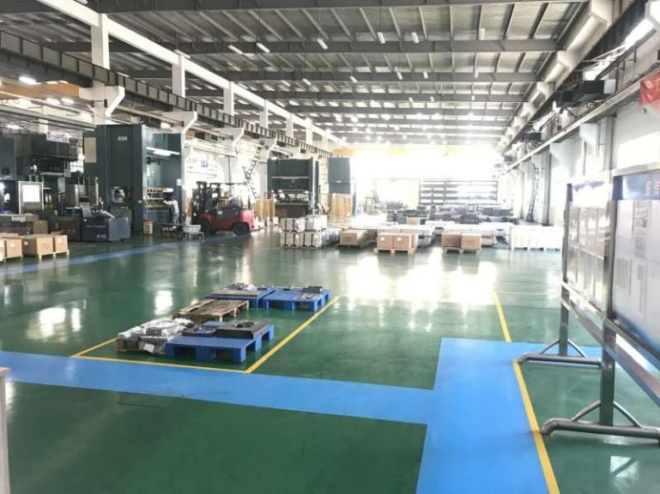 |  |  |  |  |  |  |  |  |  |  |  |  |  |  | 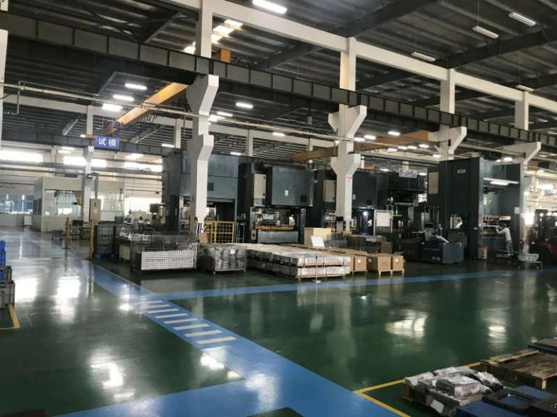
producing workshop
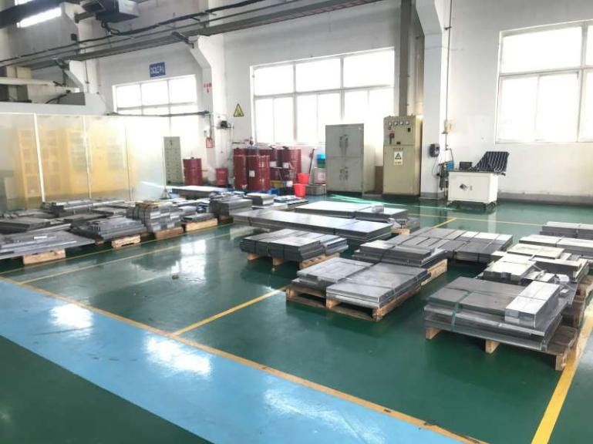 |  |  |  |  |  |  |  |  |  |  |  |  |  |  | 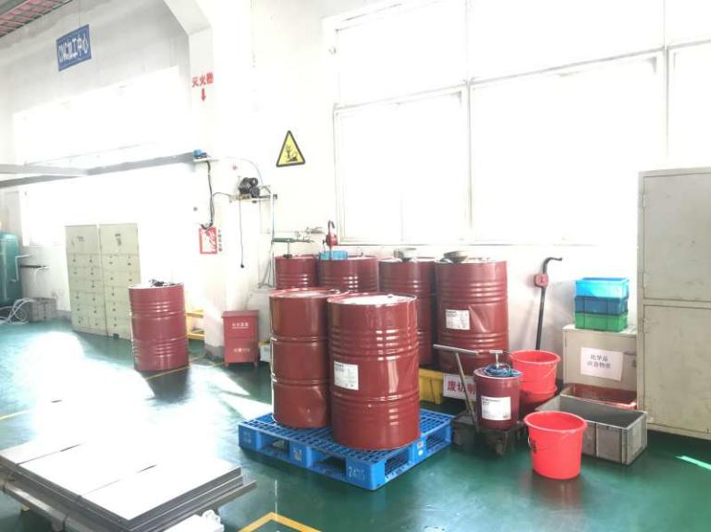
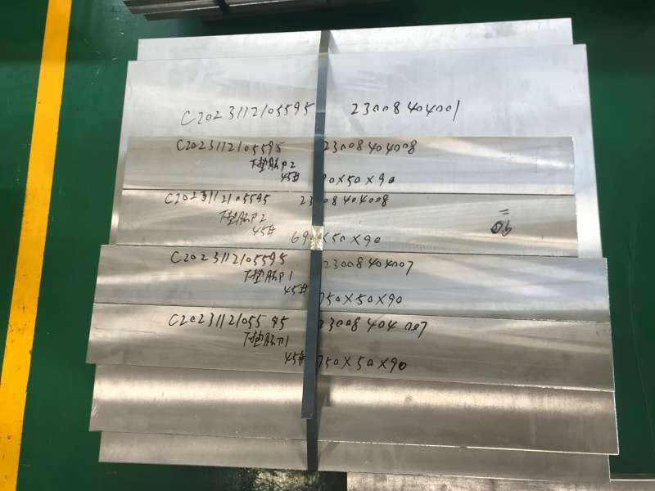 |  |  |  |  |  |  |  |  |  |  |  |  |  |  | 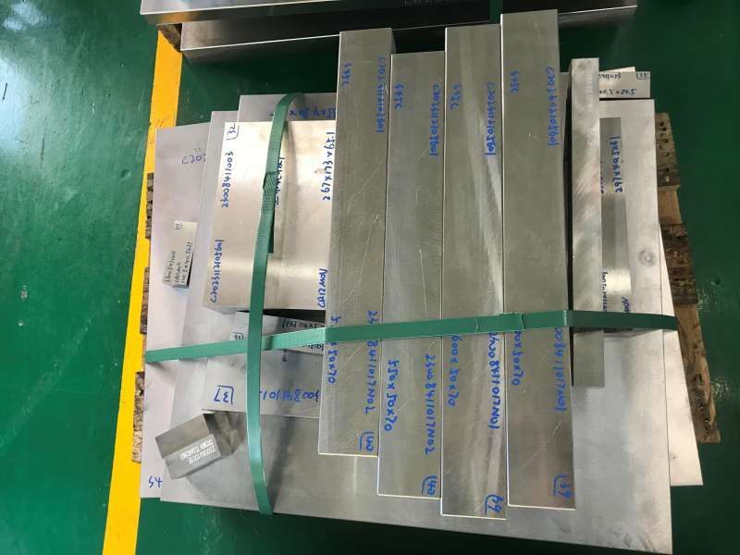
Raw material storage area
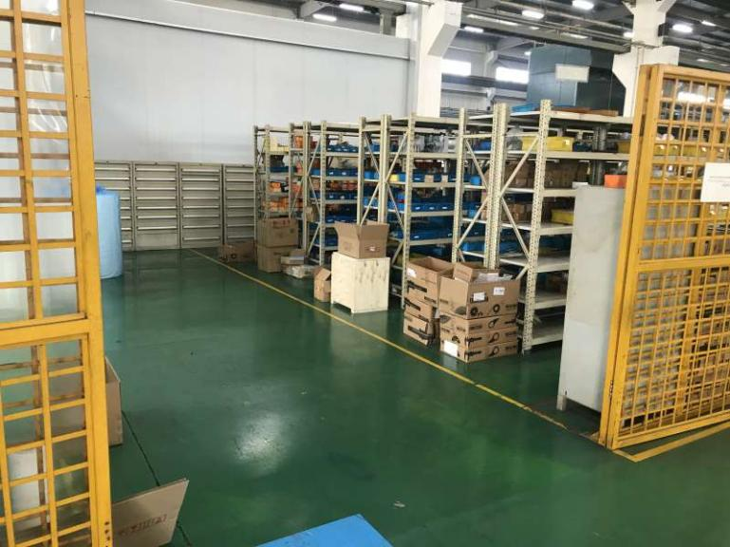 |  |  |  |  |  |  |  |  |  |  |  |  |  |  |  | 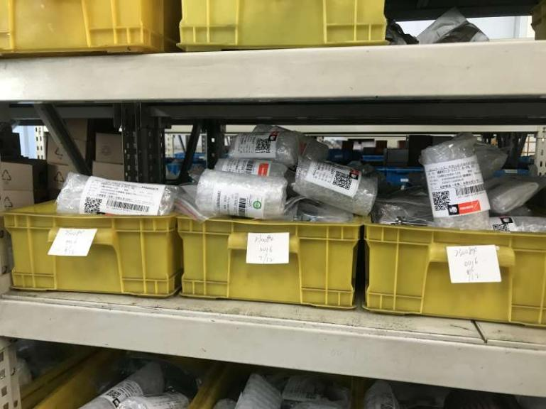
 |  |  |  |  |  |  |  |  |  |  |  |  |  |  |  | 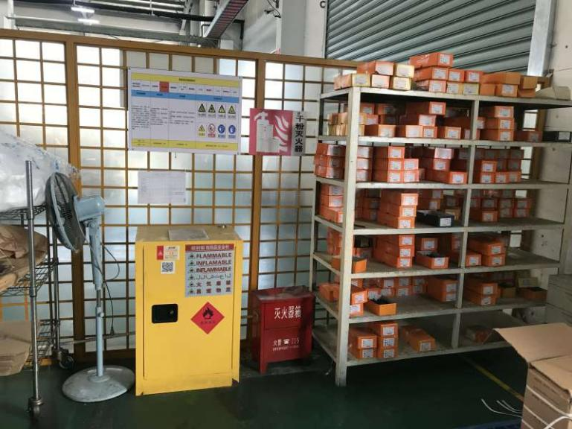
Purchased Parts warehouse
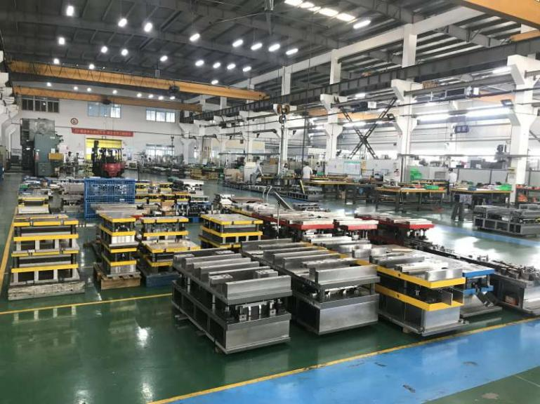 |  |  |  |  |  |  |  |  |  |  |  |  |  |  |  | 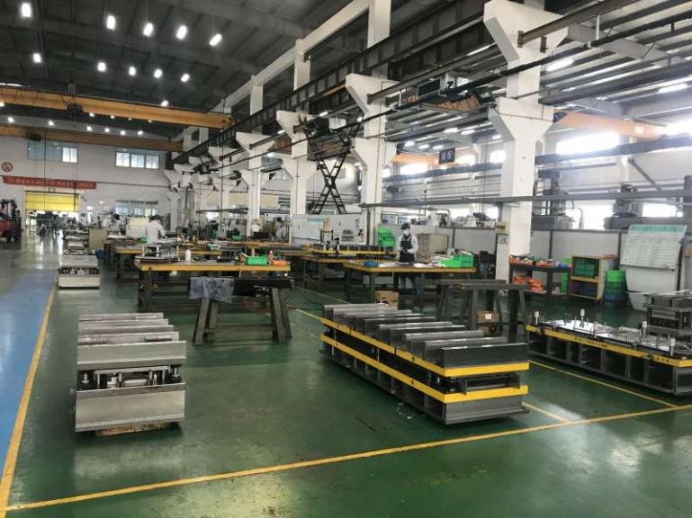
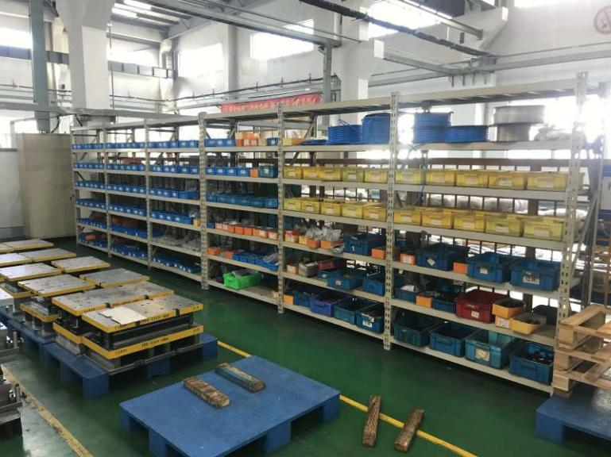 |  |  |  |  |  |  |  |  |  |  |  |  |  |  |  | 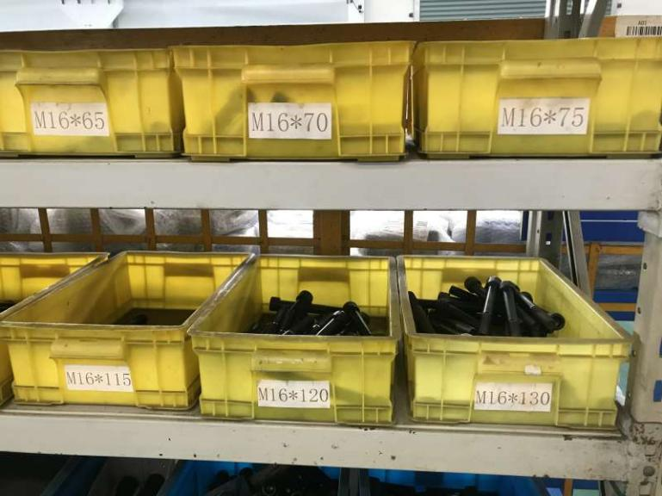
assembly section
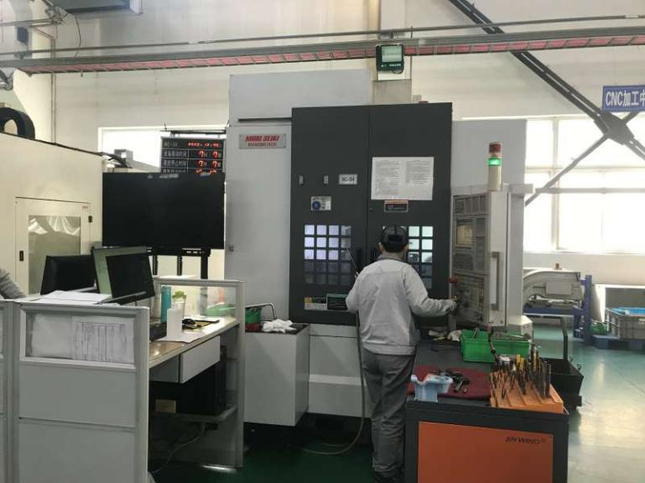 |  |  |  |  |  |  |  |  |  |  |  |  |  |  |  | 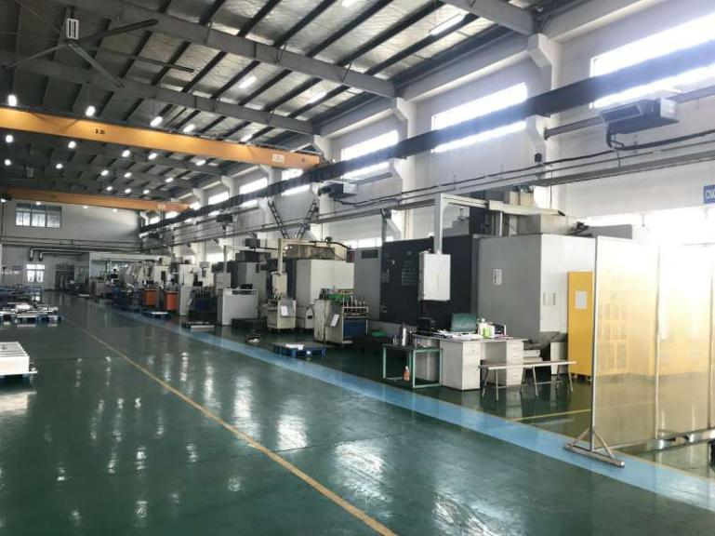
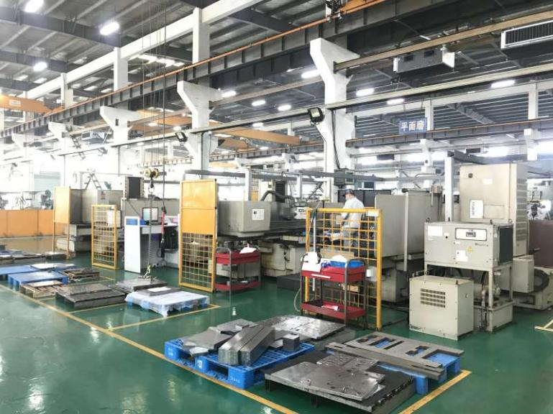 |  |  |  |  |  |  |  |  |  |  |  |  |  |  |  | 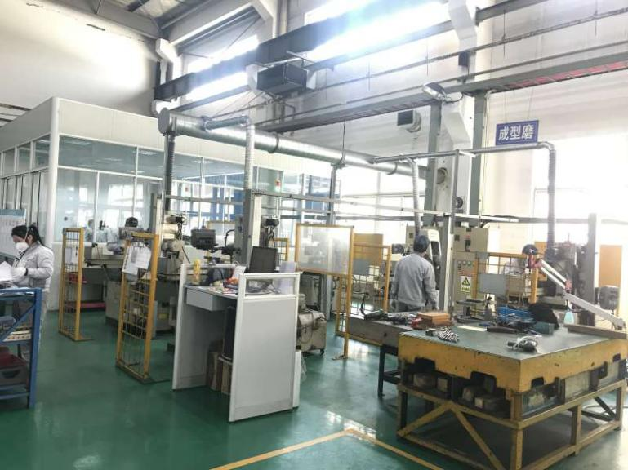
 |  |  |  |  |  |  |  |  |  |  |  |  |  |  |  | 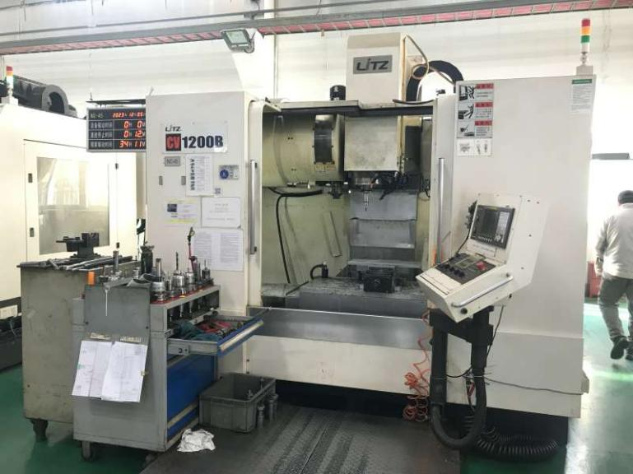
 |  |  |  |  |  |  |  |  |  |  |  |  |  |  |  | 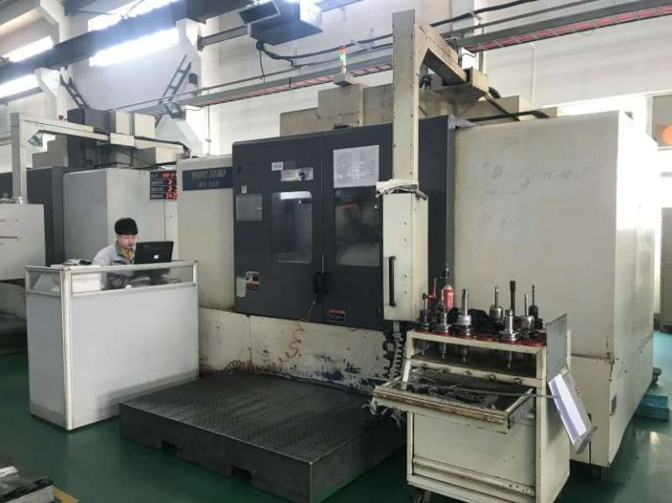
CNC machining area (22sets)
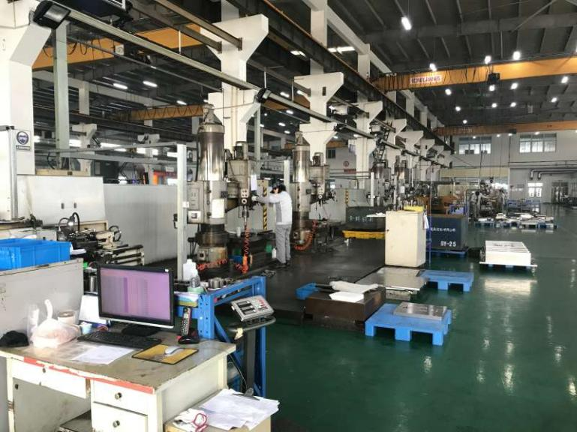 |  |  |  |  |  |  |  |  |  |  |  |  |  |  |  | 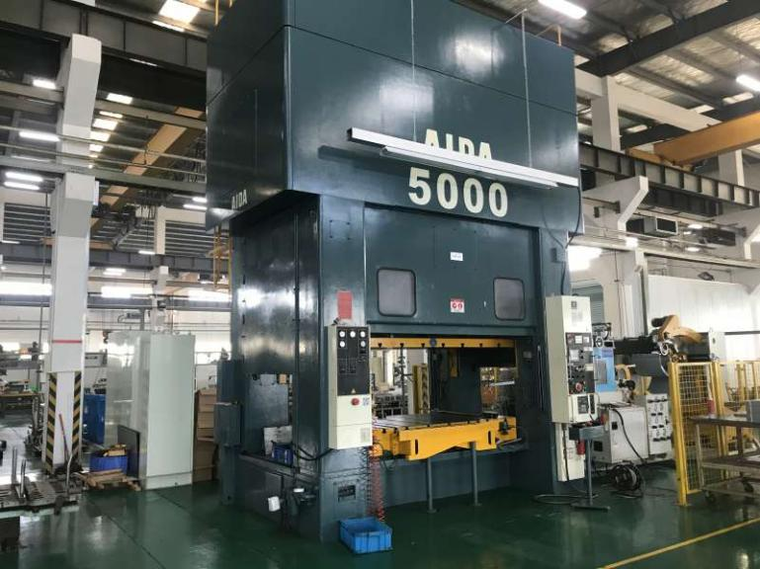
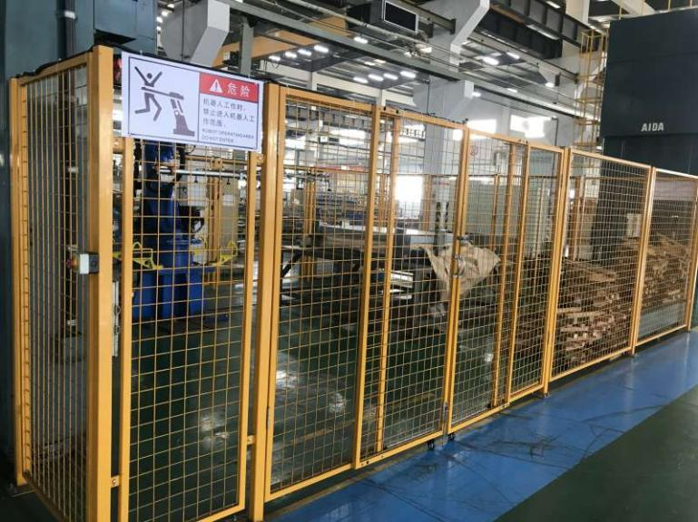
The daily inspection of the equipment uses the QR code electronic version
Mold testing production area
 |  |  |  |  |  |  |  |  |  |  |  |  |  |  |  | 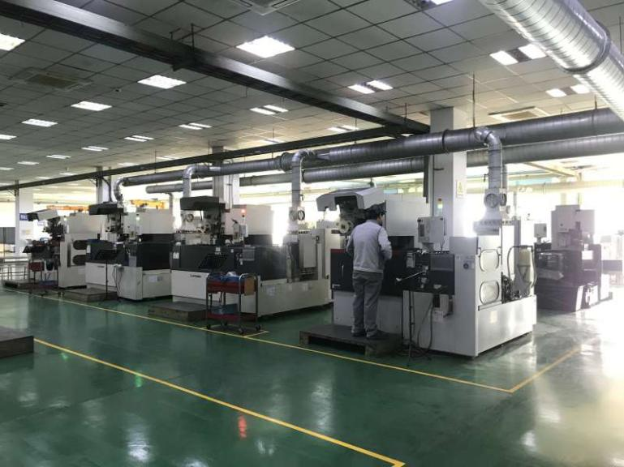
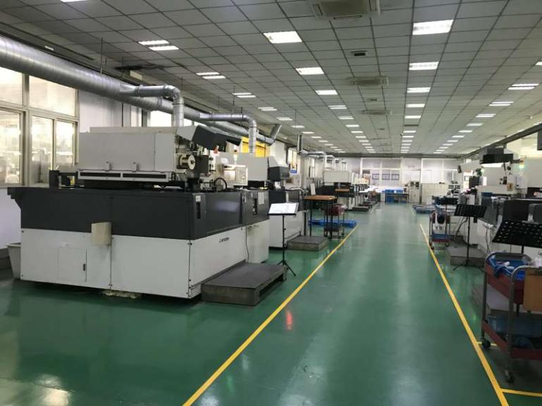 |  |  |  |  |  |  |  |  |  |  |  |  |  |  |  | 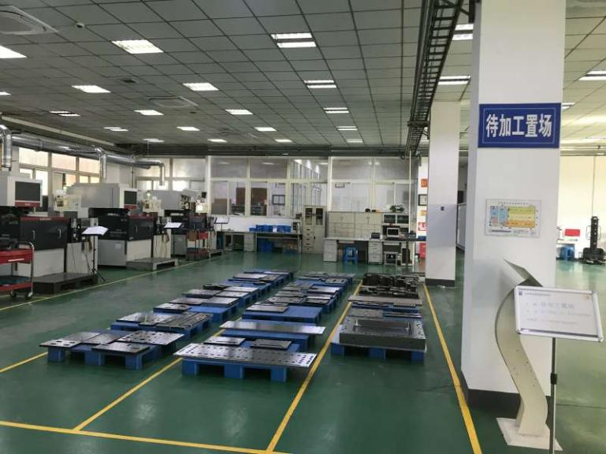
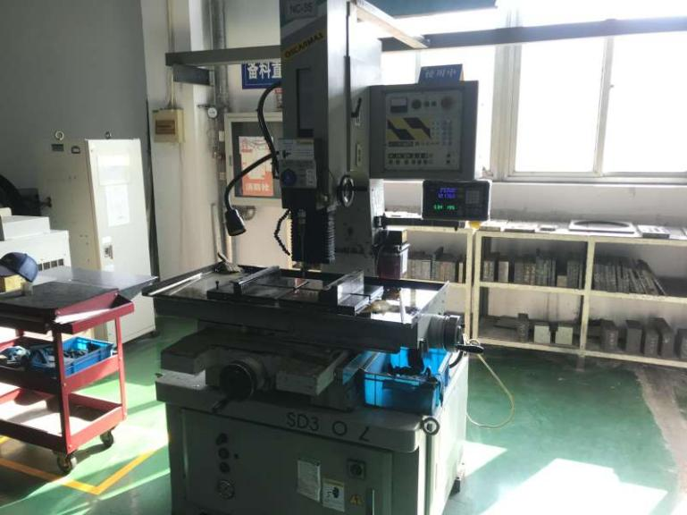
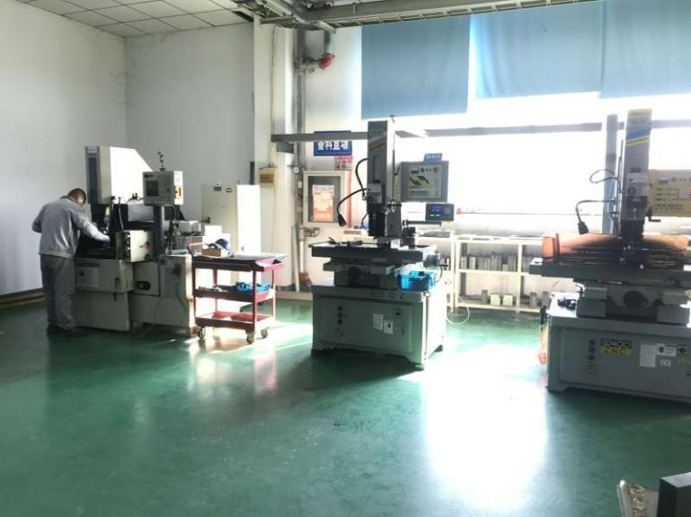 |  |  |  |  |  |  |  |  |  |  |  |  |  |  |  | 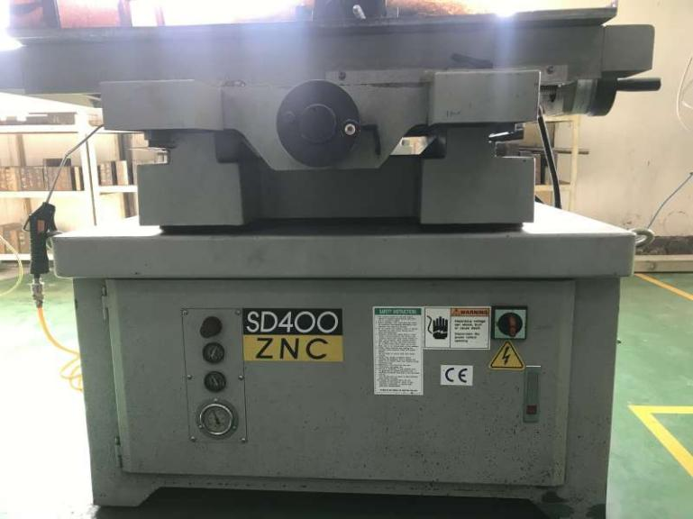
 |  |  |  |  |  |  |  |  |  |  |  |  |  |  |  | 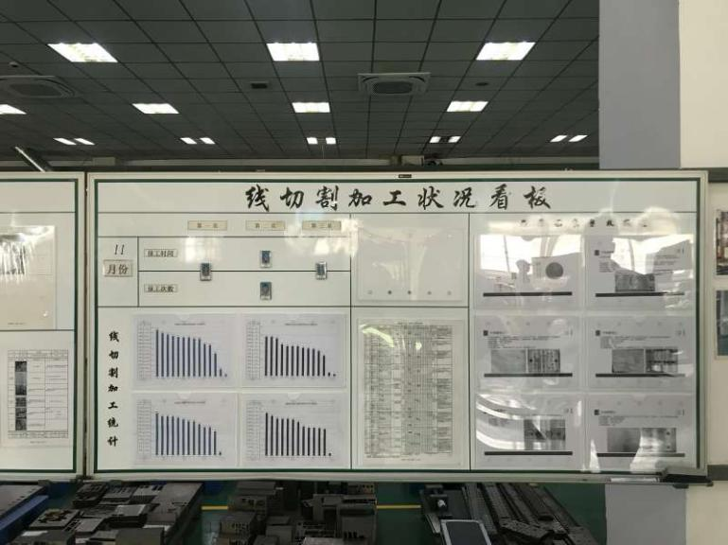
Wire cutting processing area
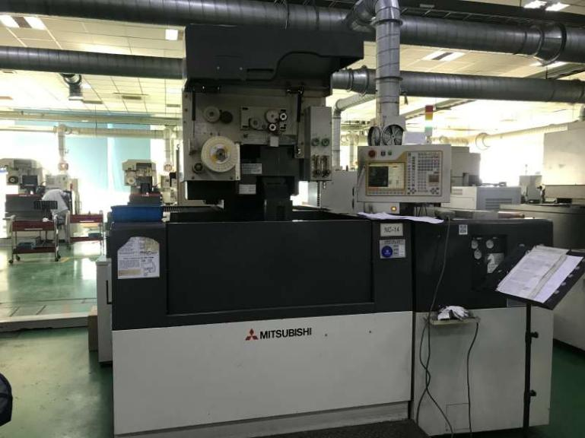 |  |  |  |  |  |  |  |  |  |  |  |  |  |  |  | 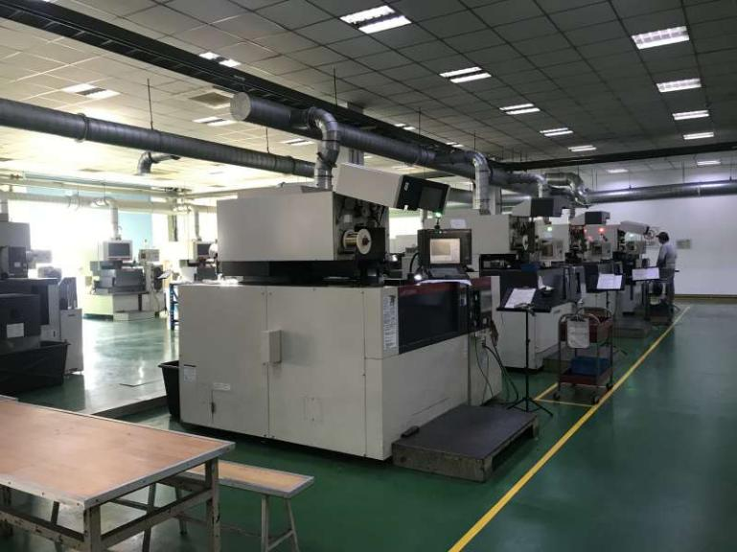
MITSUBISHI Small wire cutting machina (20sets)
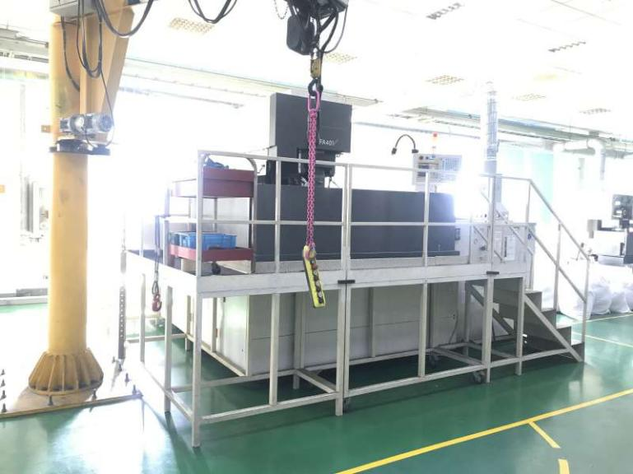 |  |  |  |  |  |  |  |  |  |  |  |  |  |  |  | 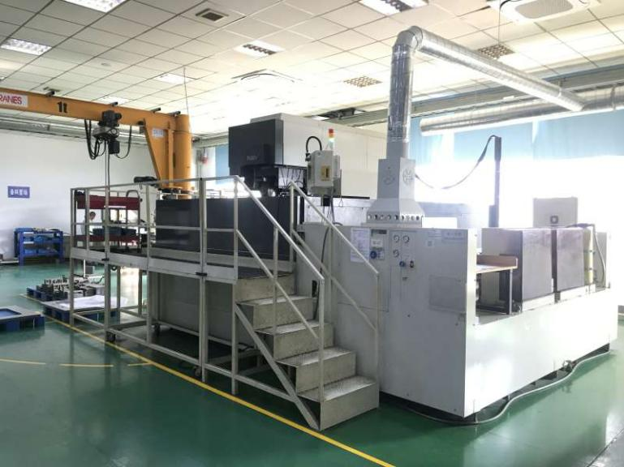
MITSUBISHI Large wire cutting machine (2 sets)
 |  |  |  |  |  |  |  |  |  |  |  |  |  |  |  | 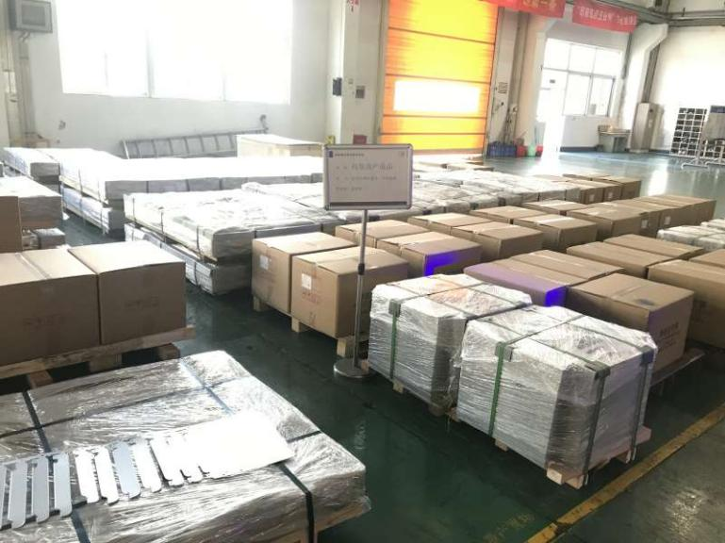
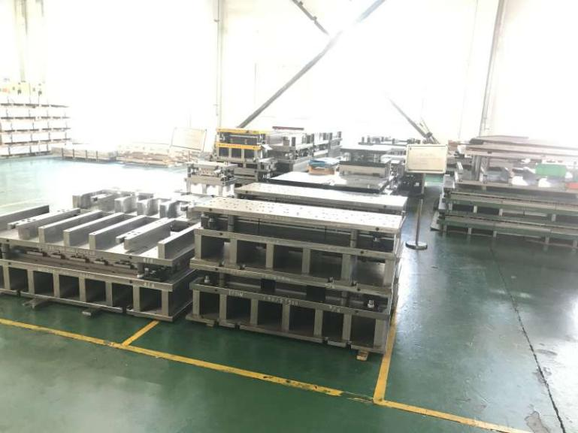 |  |  |  |  |  |  |  |  |  |  |  |  |  |  |  | 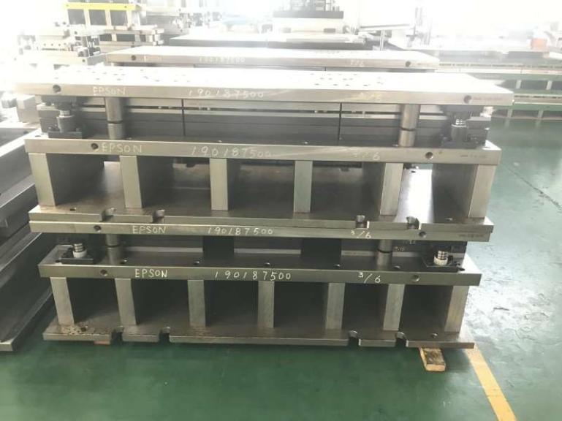
Finished product placement area
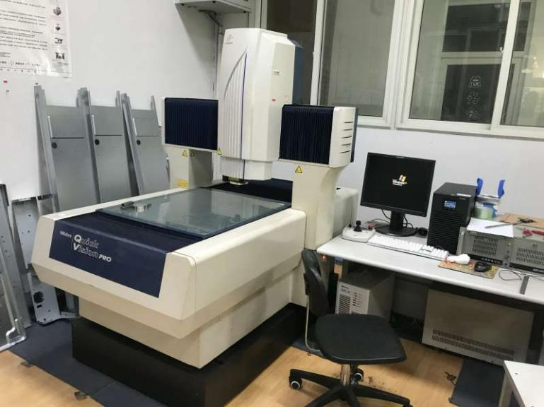 |  |  |  |  |  |  |  |  |  |  |  |  |  |  |  | 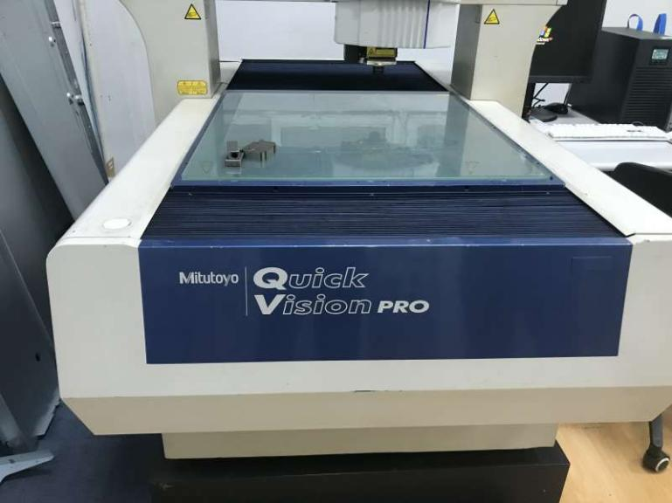
Mitotuyo Vision measuring system
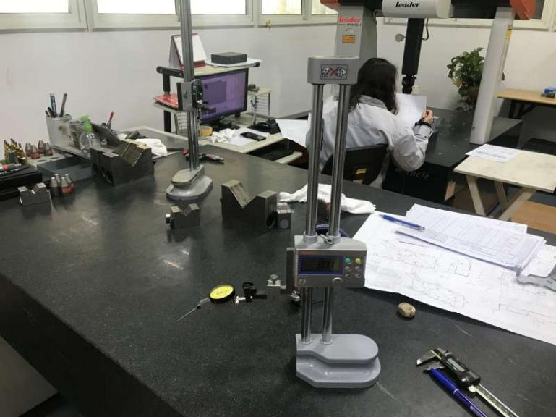 |  |  |  |  |  |  |  |  |  |  |  |  |  |  |  | 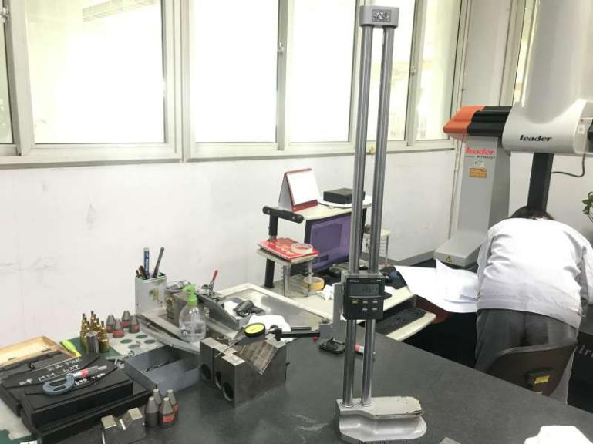
height gauge
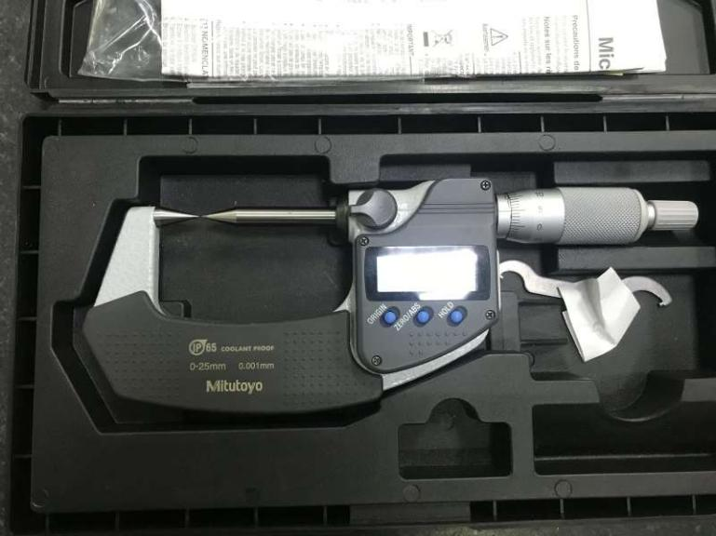
micrometer
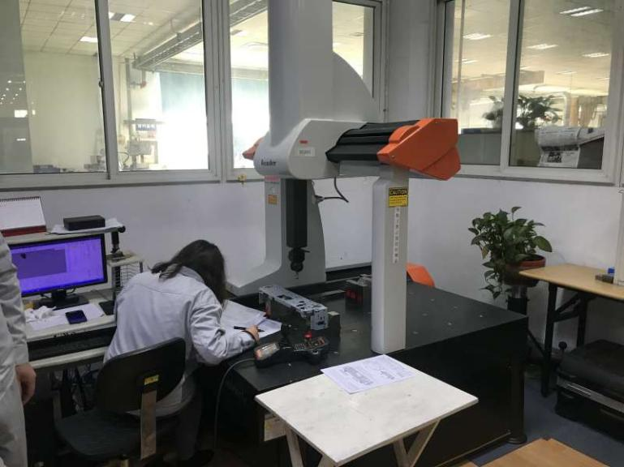 |  |  |  |  |  |  |  |  |  |  |  |  |  |  |  | 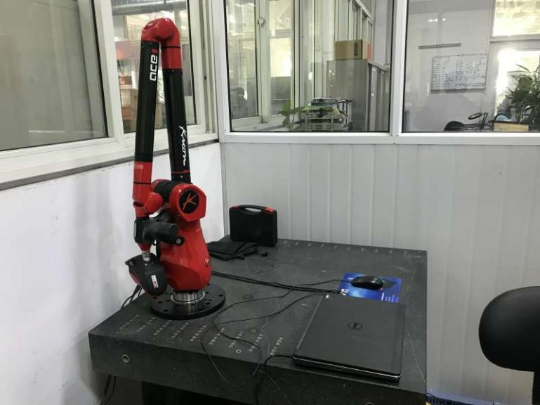
THREE COORDINATE MEASURING INSTRUMENT |  |  |  |  |  |  |  |  |  |  |  |  |  |  |  | 3D Scanner
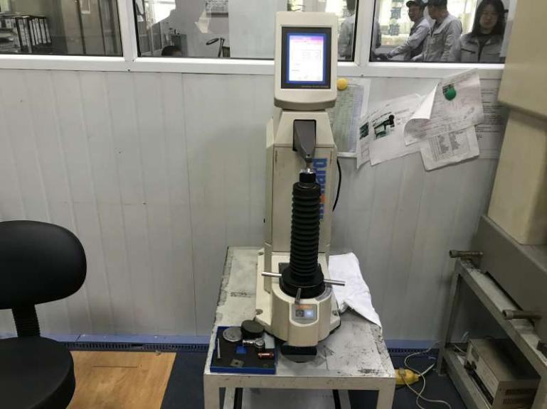
Metal hardness tester |  |  |  |  |  |  |  |  |  |  |  |  |  |  |  | record of survey
Partial verification certificate of testing instrument
The End

